Computer Language Codincg Concept

Commands Anywhere in a Diagram
The article Commands Anywhere explained the concept of commands being able to freely move around. In the current article, the idea is further clarified with diagrams.

You can put the executable object inside another object:



You can reference an executable object:

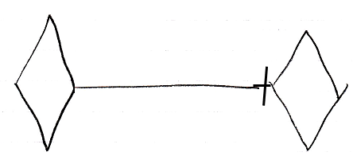

Yes, you can put an executable object inside a command definition:

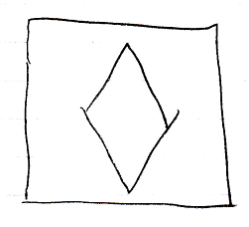

But you can also put an executable object inside a class:



You can run an execution inside an object, sort of like having an execution run inside a specific folder:

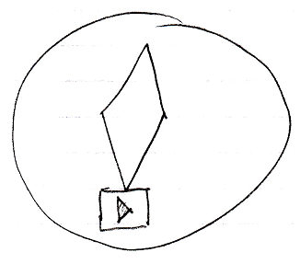

You can also run the execution inside your user object and sort of take it along with you, whereever you go into the digital world.

You can also run an execution globally on a site.

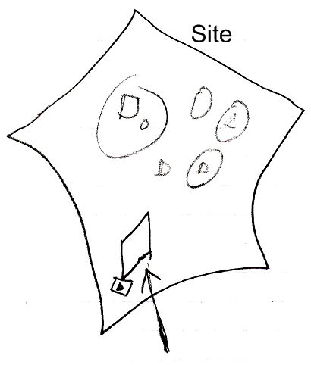

Executions can also be placed in a list. No problem. You can run each item in the list individually.

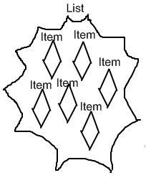

See also: Commands Anywhere, Commands

Author & Copyright: Jan-Joost van Zon Date: August 28, 2008 – August 28, 2008 Location: Oosterhout, The Netherlands Status: Finished

